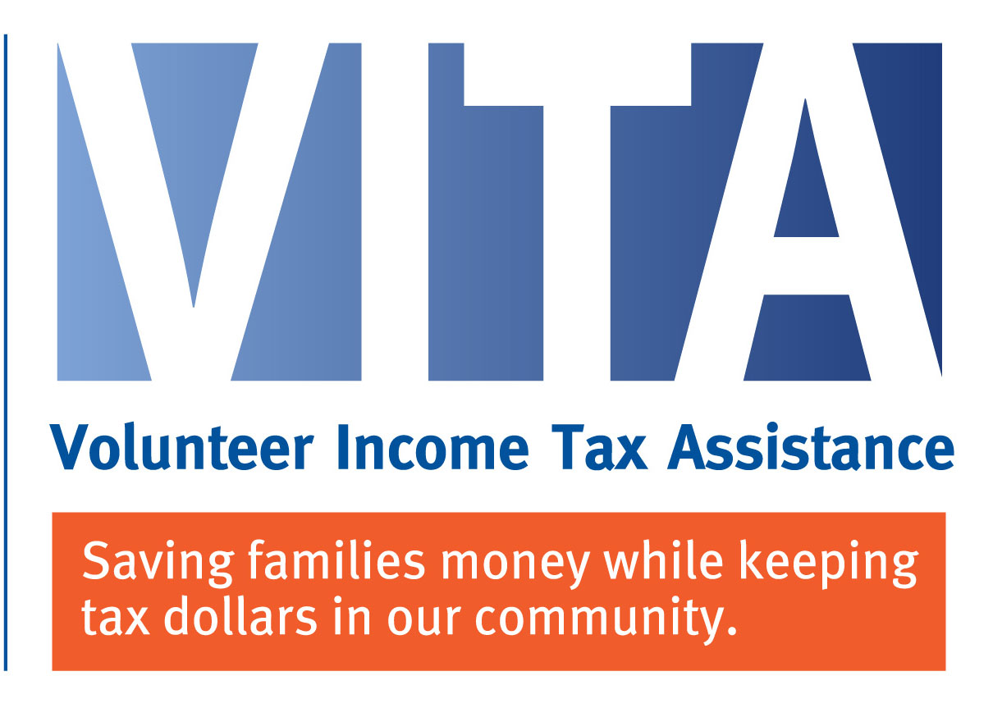

The VITA (Volunteer Income Tax Assistance) program is a program initiated by the Internal Revenue Service (IRS) that offers free tax preparation to low-to-moderate income households who cannot prepare their own taxes or afford to pay a paid preparer. Low-to-moderate income households, whose annual income is under $56,000, may receive free tax preparation assistance through VITA sites. There is no income limit on DIY online preparation through www.utahtaxhelp.org.

VITA sites will be opening February 3, 2020. Locations are as follows:

Department of Workforce Services: Tuesday, Wednesday, & Thurday from 9:00 AM – 12:00 PM
Bear River Association of Governments: Monday - Thursday from 6:00 PM-9:00 PM
Usu (Business Building): Tuesday 6:00 PM-8:00 PM

To find out if a household is eligible for VITA services, dial 2-1-1 to speak with a representative and schedule an appointment starting January 27, 2020.

El programa VITA (Volunteer Income Tax Assistance) es un programa iniciado por el Servicio de Impuestos Internos (IRS) que ofrece preparación gratuita de impuestos a los hogares de ingresos bajos a moderados que no pueden preparar sus propios impuestos o pagar un preparador. Para calificar para el servicio los ingresos tienen que ser menos de $56,000 al año. No hay límite de ingresos para la preparación en línea a través de www.utahtaxhelp.org.

Los sitios de VITA se abrirán el 3 de Febrero del 2020. Las ubicaciones son las siguientes:

Departamento de Workforce Services: Martes, Miércoles y Jueves de 9:00 a.m. a 12:00 p.m.
Bear River Association of Governments: Lunes a Jueves de 6:00 p.m. a 9:00 p.m.
USU (Business Building): Martes 6:00 PM a 8:00 PM

Para saber si un hogar es elegible para los servicios de VITA, marque 2-1-1 para hablar con un representante y programe una cita a partir del 27 de enero del 2020.

